



May 2012

AMS THERMO pDR1100 AEROSOL TRANSMITTER

Table of contents:

1. Purpose 3

2. Design 3

3. Installation 4

4. Maintenance 6

**Table of figures:**

Figure 1 General view 3

Figure 2 PDR measuring instrument 4

Figure 3 Flow inducing deflector plate 4

Figure 4 PRATLEY Electrical junction box **Error! Bookmark not defined.**

**AMS THERMO PDR 1100 AEROSOL TRANSMITTER**

AMS Haden has designed a real-time aerosol transmitter for use in conjunction with telemetry monitoring systems such as mine fire Environmental Monitoring systems. The instrument may be used to identify trends in dust concentration in air passing by the instrument. The instrument can be installed in underground airways and other areas where workers are at risk of exposure to high dust levels.

# Purpose

The instrument has been designed to provide real-time dust monitoring. This will enable mine ventilation engineers and occupational hygienists to identify trends and take remedial action immediately. This information will enhance the efficacy of remedial action and planning of dust suppression measures.

# Design

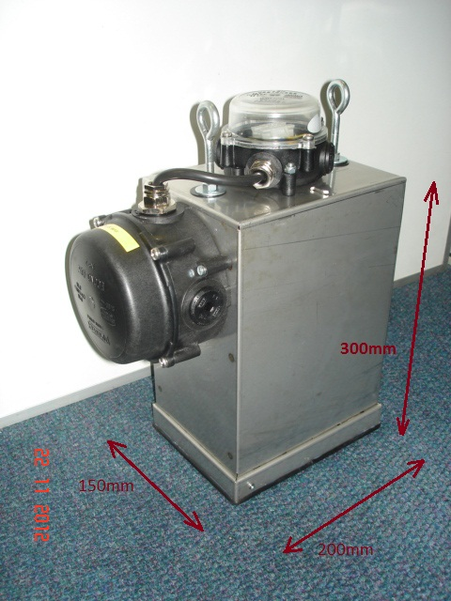The instrument is housed in a robust steel enclosure. The design of the housing is compact making handling, transport, and installation relatively simple and not unduly cumbersome.

The enclosure is designed to entrain air over the sensor bridge of the pDR instrument. The flow of air over the sensor bridge is controlled by adjustment of a deflector plate. This flow should be adequate to ensure a rapid response to changing aerosol concentrations but not reach the conveying velocity of the larger particles that will foul the sensor bridge.

The measuring instrument is the well-known and proven pDR1000 nephelometric (i.e. photometric) monitor. The instrument is powered by an on-board 9 VDC power supply, which is fed by a 24 VDC supply from a slave PLC. The on-board power supply is equipped with a battery backup providing approximately 12 hours of uninterrupted operation. In normal operation, the instrument is powered by the telemetry slave PLC. In the event of a power supply, interruption the battery backup will maintain supply to the instrument. Real-Time dust readings are transmitted to the Control Centre via the slave PLC.

Figure General view with two PRATLEY connection boxes

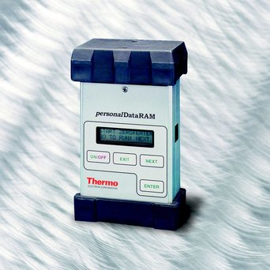The instrument range is user selectable. However, the factory setting is 0 to 4 mg/m³.

**NB: This is the recommended range setting for this application.**

The instrument enclosure is fitted with a clear Perspex window making the instrument display visible to the user. The instrument can therefore be operated and viewed without removing it from the enclosure. The instrument keypad is accessible from the entrainment opening at the bottom of the enclosure.

# Installation

The mine ventilation practitioner should identify a suitable position for installation of the instrument.

Figure PDR measuring instrument

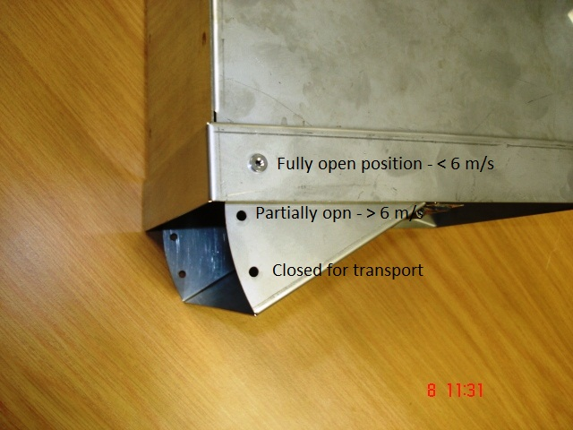The unit is intended to be installed in close proximity to the hanging wall of the excavation, out of the way of rolling stock and out of reach for pedestrians. This will help to prevent damage and tampering.

The air conveying velocity over the sensor bridge is determined by two factors:

1. The velocity over the enclosure
2. ii) The position of the deflector plate

The deflector plate has three preset positions:

1. Fully closed for transport
2. Partially open for velocities exceeding 6 m/sec

Figure Flow inducing deflector plate

1. Fully open for velocities below and up to 6 m/sec

The deflector plate position is secured by means of an M3 screw as shown in Figure 3. The instrument must be installed with the deflector plate opening facing DOWNWIND of the passing ventilation current. The air velocity should be measured at the base of the deflector plate with the instrument already fixed in position.

The enclosure is fitted with two suspension eyebolts on the top of the enclosure. Suitable cable-ties can be used for easy and quick installation and removal.

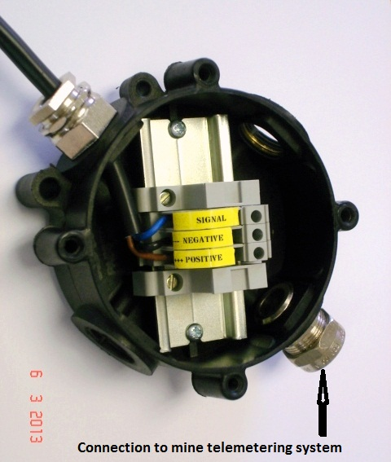**Electrical connection:**

Two PRATLEY ECONO junction boxes are fitted to the exterior of the enclosure.

The 24 VDC power supply and the signal cable are connected at the terminals mounted on the DIN rail inside the No 0 PRATLEY ECONO box – See Figure 4.

The size No 2 PRATLEY ECONO box contains the power supply unit (printed circuit board) with backup battery.

IT IS NOT NECESSARY FOR THE MINE TO MAKE ANY CONNECTIONS INSIDE THE No 2 PRATLEY ECONO BOX.

**Analog Output Signal Configuration:**

The analog output signal from the instrument is 4 to 20 mA DC. The PLC should be programmed according the range setting on the instrument output.

Figure PRATLEY ECONO No 2 box labeled connections

Instrument range = 0.0 – 4.0mg/m³.

Therefore 0.00mg/m³ = 4 mA & 4.00mg/m³ = 20mA.

**NB: This is the recommended range setting for this application. The Analog Signal Output Range can only be changed via PC.**

**Installation steps:**

* Identify installation position
* Fix unit in a suitable position (Out of reach from rolling stock and pedestrians in unobstructed airflow)
* Measure air velocity below the deflector plate
* Open the deflector plate to the correct position according to the velocity measured and secure with M3 screw
* Fully closed for transport
* Partially open for velocities exceeding 6 m/sec
* Fully open for velocities below and up to 6 m/sec
* Remove the PRATLEY No 2 junction box lid
* Fit cable gland and feed PLC power supply and signal cable into junction box. See figure 4.
* Secure gland and cable
* Make cable connections to the block connectors on the DIN RAIL as per labels.
* Switch the PDR Instrument inside the enclosure “ON” and observe the display (through the Perspex pane) to confirm that the instrument is operational Proceed through the start-up-mode steps (3 key strokes) as per the OEM manual (PAGE 42) to set the instrument in the RUN mode.

|  |  |
| --- | --- |
| **KEY STROKE** | **INSTRUMENT DISPLAY** |
| **ON/OFF** | START ZERO : ENTER  GO TO RUN : NEXT |
| **NEXT** | START RUN : ENTER  READY : NEXT |
| **ENTER** | LOGGING DISABLED |
| **After 5 seconds** | CONC 0.047 mg/m³  TWA 0.039 MG/M³ |
| The instrument is now running and the readings will be transmitted. | |

* Refit junction box lid
* Confirm signal transmission with control room

# Maintenance

The instrument requires minimal maintenance in this application. If drift is evident, over time, the instrument can be removed from the enclosure and the zero setting performed using the Z-Pouch (See OEM Manual) in a low dust concentration or dust free environment in accordance with the OEM instructions and with the supplied OEM equipment. If the Zero function cannot be carried out successfully, the instrument should be returned to AMS Haden for service and recalibration.

In spite of the careful design of the instrument, dust may still settle on the sensor bridge. If after time, the instrument becomes insensitive and readings drop below previous background levels the instrument should be sent to AMS Haden for servicing.

If the power supply is interrupted for longer than the PLC backup period and the instrument back-up period the instrument will switch “OFF” and will have to be switched “ON” manually and set to RUN mode when the power is restored.

**Notes:**

1. **The entire operation and specification of the pDR measuring instrument is contained in the OEM Manual. Please consult this manual for all matters relating the instrument. (See Addendum 1)**

END OF DOCUMENT